Scenario-Based Requirement Analysis and Software Requirement Specification
Project Title
SmartRetail Vision: AI-Powered Autonomous Inventory Monitoring and Shelf Analytics

1. Scenario-Based Requirement Analysis
1.1 Business Domain
The proposed system belongs to the Retail Management, Artificial Intelligence, Computer Vision, and Inventory Analytics domain.
Modern retail stores need to maintain accurate product availability and shelf organization. Traditional inventory management relies heavily on manual shelf inspections and barcode scanning. These methods are time-consuming and may not provide real-time information about shelf-level problems.
SmartRetail Vision uses AI-powered computer vision, deep learning, and inventory analytics to continuously monitor retail shelves and identify:
- Empty shelves
- Stock shortages
- Misplaced products
- Incorrect shelf placement
- Product visibility problems
- Shelf utilization
- Inventory anomalies
The system also uses historical sales and shelf information to support inventory demand prediction and replenishment planning.

1.2 Stakeholders
Stakeholder | Role / Interest
Store Manager | Monitors inventory, shelf status, alerts, and analytics
Inventory Manager | Handles stock levels and replenishment
Store Employees | Respond to alerts and restock products
Retail Chain Administrator | Manages multiple stores and system configuration
Merchandising Manager | Uses shelf analytics for product placement decisions
Business Management | Uses reports and predictions for strategic decisions
Customers | Benefit indirectly from better product availability
IT/System Administrator | Maintains system, users, cameras, and integrations
AI/ML Engineer | Develops and maintains computer vision models
Existing Inventory System | Provides inventory and sales information
Smart Cameras/IoT Devices | Capture shelf information

1.3 Existing Challenges
The current retail inventory process faces the following challenges:
- Manual shelf inspection requires significant employee time.
- Human inspection can result in errors.
- Stockouts may remain undetected until a customer reports them.
- Barcode scanning does not continuously monitor shelf conditions.
- Misplaced products are difficult to detect automatically.
- Periodic inventory verification does not provide real-time visibility.
- Overstocking can increase storage costs and product waste.
- Inventory information may become outdated.
- Managers lack immediate shelf-level analytics.
- Historical inventory information is not always effectively used for demand prediction.

1.4 Proposed Solution
SmartRetail Vision will use smart cameras and AI-based computer vision to continuously capture shelf images.
The AI model will analyze these images and identify products, their locations, and shelf conditions. The system will compare detected shelf conditions with expected inventory information.
When an anomaly is identified, the system will generate an alert for the responsible employee or manager.
The system will also analyze historical sales and shelf information to generate:
- Inventory reports
- Shelf utilization analytics
- Product visibility analytics
- Stockout trends
- Replenishment recommendations
- Demand predictions

1.5 System Objectives
The main objectives are:
- To automatically monitor retail shelves using computer vision.
- To detect empty shelves and stock shortages.
- To identify misplaced products.
- To analyze shelf images using deep learning.
- To generate real-time replenishment alerts.
- To provide shelf utilization and product visibility analytics.
- To predict future inventory demand.
- To integrate with existing inventory management systems.
- To reduce manual inventory inspection.
- To improve product availability and customer satisfaction.

2. Functional and Non-Functional Requirements
2.1 Functional Requirements
FR-01: User Authentication
The system shall allow authorized users to log in securely.
FR-02: User Role Management
The system shall provide different access permissions for administrators, managers, inventory employees, and other users.
FR-03: Camera Integration
The system shall connect with smart cameras installed in retail stores.
FR-04: Shelf Image Capture
The system shall receive and process images/video frames captured from shelf-monitoring cameras.
FR-05: Product Detection
The system shall identify products present on shelves using an AI-based object detection model.
FR-06: Empty Shelf Detection
The system shall detect shelves or shelf sections where products are missing.
FR-07: Stock Shortage Detection
The system shall identify products whose shelf quantity is below the predefined threshold.
FR-08: Misplaced Product Detection
The system shall identify products that are located in incorrect shelf positions.
FR-09: Inventory Comparison
The system shall compare computer vision results with inventory records.
FR-10: Anomaly Detection
The system shall identify inconsistencies between expected inventory and observed shelf conditions.
FR-11: Real-Time Alerts
The system shall generate alerts when stock shortages, empty shelves, or misplaced products are detected.
FR-12: Replenishment Notification
The system shall notify appropriate employees when products require replenishment.
FR-13: Inventory Dashboard
The system shall display current inventory and shelf status through a dashboard.
FR-14: Shelf Analytics
The system shall provide analytics regarding shelf utilization and product visibility.
FR-15: Historical Data Analysis
The system shall store historical shelf and inventory information for analysis.
FR-16: Demand Prediction
The system shall use historical sales and shelf data to predict future product demand.
FR-17: Reporting
The system shall generate inventory and shelf analytics reports.
FR-18: Inventory System Integration
The system shall exchange relevant inventory and sales data with existing retail inventory management systems.
FR-19: Alert Management
Users shall be able to view, acknowledge, and track inventory alerts.
FR-20: System Administration
Administrators shall be able to manage users, cameras, shelves, products, thresholds, and system configurations.

3. Non-Functional Requirements
3.1 Performance
- The system should process shelf images with minimal delay.
- Critical inventory anomalies should be detected as close to real time as practical.
- Dashboard information should load quickly.
- The system should support multiple cameras simultaneously.
3.2 Security
- Only authorized users shall access the system.
- Passwords shall be securely stored.
- Role-based access control shall be implemented.
- Camera and inventory data shall be protected during transmission.
- Sensitive business information shall not be accessible to unauthorized users.
3.3 Reliability
- The system should operate continuously during store operating hours.
- Temporary camera/network failures should not cause the entire system to fail.
- The system should recover gracefully from software or hardware failures.
- Data should be backed up regularly.
3.4 Usability
- The dashboard should be simple and easy to understand.
- Alerts should clearly indicate the problem and affected product/shelf.
- Managers should be able to access important information with minimal navigation.
- Reports should be presented using understandable tables and charts.
3.5 Scalability
- The system should support a small retail store initially.
- It should be scalable to supermarkets, malls, and large retail chains.
- Additional cameras and stores should be added without major architectural changes.
3.6 Maintainability
- AI models should be replaceable or upgradeable.
- The system should use modular components.
- Logs should be maintained for troubleshooting.
- System configuration should be manageable without modifying source code.
3.7 Availability
- The system should be available throughout store operating hours.
- Camera and network failures should be detected and reported.
- Important inventory data should remain accessible during temporary component failures.
3.8 Accuracy
- The AI model should accurately identify supported products.
- False alerts should be minimized.
- Product detection performance should be periodically evaluated and improved.

4. Actors and Use Cases
4.1 Primary Actors
1. Store Manager
Uses the system to monitor inventory, view analytics, and respond to alerts.
2. Inventory Employee
Receives replenishment alerts and performs shelf restocking.
3. Retail Administrator
Manages users, stores, cameras, products, and system settings.
4. Merchandising Manager
Uses shelf analytics and product visibility information for merchandising decisions.

4.2 Secondary Actors
5. Smart Camera
Captures shelf images and sends them to the system.
6. Existing Inventory Management System
Provides inventory and sales information to SmartRetail Vision.
7. AI/ML Model
Processes shelf images and detects products and shelf anomalies.
8. Notification Service
Delivers alerts and notifications to relevant users.

5. Major Use Cases
Actor | Major Use Cases
Store Manager | Login, Monitor Shelves, View Inventory, View Alerts, View Analytics, Generate Reports
Inventory Employee | Login, View Alerts, Check Shelf, Restock Products, Update Status
Retail Administrator | Manage Users, Manage Cameras, Manage Products, Configure Thresholds, Manage Stores
Merchandising Manager | View Shelf Analytics, Analyze Product Visibility, Analyze Shelf Utilization
Smart Camera | Capture Images, Send Shelf Data
Inventory Management System | Send Inventory Data, Send Sales Data, Receive Inventory Updates
AI/ML Model | Detect Products, Detect Empty Shelves, Detect Misplaced Products, Identify Anomalies
Notification Service | Send Alerts, Send Replenishment Notifications

7. Software Requirement Specification (SRS)
7.1 Introduction
7.1.1 Purpose
The purpose of this SRS is to define the functional and non-functional requirements of SmartRetail Vision, an AI-powered autonomous inventory monitoring and shelf analytics system.
The system aims to automate retail shelf monitoring using computer vision and deep learning while providing real-time inventory insights, anomaly detection, alerts, analytics, and demand prediction.
7.1.2 Intended Audience
This document is intended for:
- Software developers
- AI/ML developers
- Project managers
- Retail managers
- System administrators
- Test engineers
- Business stakeholders
- Project evaluators
7.1.3 Product Perspective
SmartRetail Vision operates as an intelligent layer between physical retail shelves and existing inventory management systems.
Smart Cameras
↓
Image Acquisition
↓
Computer Vision / AI
↓
Product & Shelf Detection
↓
Inventory Comparison
↓
Anomaly Detection
↓
Alerts + Analytics
↓
Manager / Employee
↓
Replenishment Action

8. Problem Description
Retail stores commonly depend on manual shelf inspection and periodic inventory verification. These approaches require considerable labor and may fail to detect stock shortages and misplaced products quickly.
A product may be physically unavailable on the shelf even though the inventory database indicates that stock exists in the store.
SmartRetail Vision addresses this problem by continuously analyzing shelf images and comparing observed shelf conditions with inventory information.

9. Scope of the System
In Scope
The proposed system includes:
- Smart camera integration
- Shelf image acquisition
- AI-based product detection
- Empty shelf detection
- Stock shortage detection
- Misplaced product detection
- Inventory comparison
- Real-time alerts
- Replenishment notifications
- Shelf analytics
- Product visibility analysis
- Shelf utilization analysis
- Demand prediction
- Inventory reports
- Existing inventory system integration
- User and role management
Out of Scope
The initial system will not directly handle:
- Automatic physical movement of products
- Autonomous robots for shelf restocking
- Customer payment processing
- Billing and checkout
- Supplier payment management
- Full warehouse robotics
- Manufacturing operations

10. Use Case Descriptions
UC-01: Monitor Retail Shelf
Actor: Store Manager
Precondition: Camera is connected and operational.
Main Flow:
- Manager logs into the system.
- Manager opens the monitoring dashboard.
- System receives shelf images from cameras.
- AI model analyzes the images.
- Products and shelf conditions are identified.
- System displays current shelf status.
- Manager reviews the results.
Postcondition: Current shelf status is available to the manager.

UC-02: Detect Stock Shortage
Actors: Smart Camera, AI Model, Inventory System
Main Flow:
- Camera captures shelf image.
- AI model detects products.
- System determines the observed quantity.
- System retrieves expected inventory information.
- System compares observed and expected conditions.
- If stock is below threshold, a shortage is detected.
- System generates an alert.
Postcondition: Stock shortage is recorded and relevant users are notified.

UC-03: Detect Misplaced Product
Actors: Smart Camera, AI Model
Main Flow:
- Camera captures shelf image.
- AI model identifies products.
- System identifies product location.
- Location is compared against the expected shelf position.
- If the product is in an incorrect position, the system identifies a misplaced product.
- An alert is generated.

UC-04: Generate Replenishment Alert
Actors: AI System, Inventory Employee
Main Flow:
- System identifies a low-stock or empty shelf.
- System generates a replenishment alert.
- Notification service sends the alert.
- Employee receives the notification.
- Employee checks the relevant shelf.
- Employee replenishes the product.
- Employee updates the status.

UC-05: View Shelf Analytics
Actor: Store Manager / Merchandising Manager
Main Flow:
- User logs into the system.
- User selects the analytics dashboard.
- System retrieves historical shelf data.
- System calculates shelf utilization and product visibility.
- System presents results through charts and reports.
- User uses the information for merchandising decisions.

UC-06: Predict Inventory Demand
Actor: Store Manager
Main Flow:
- System retrieves historical sales data.
- System retrieves historical inventory information.
- System retrieves shelf availability information.
- AI prediction model processes the data.
- System generates demand predictions.
- Predicted demand is presented to the manager.
- Manager uses the prediction for replenishment planning.

11. Data Requirements
The system will require the following data.
11.1 User Data
- User ID
- Name
- Email/Username
- Password credentials
- Role
- Store assignment
- Account status
11.2 Product Data
- Product ID
- Product name
- Category
- Brand
- Expected shelf location
- Minimum stock threshold
- Maximum stock level
- Product image/features
11.3 Shelf Data
- Shelf ID
- Store ID
- Section number
- Camera ID
- Expected products
- Shelf capacity
- Shelf status
11.4 Camera Data
- Camera ID
- Camera location
- Shelf/section mapped to camera
- Connection status
- Capture timestamp
11.5 Inventory Data
- Product ID
- Store ID
- Current stock
- Expected stock
- Reorder threshold
- Last updated time
11.6 Detection Data
- Detection ID
- Product ID
- Shelf ID
- Detected quantity
- Detection confidence
- Detection timestamp
- Detected position
11.7 Alert Data
- Alert ID
- Alert type
- Product ID
- Shelf ID
- Severity
- Timestamp
- Status
- Assigned employee
11.8 Sales Data
- Product ID
- Sales quantity
- Sales date
- Store ID
- Sales frequency

12. External Interface Requirements
12.1 User Interface
The system should provide a web-based dashboard containing:
- Login page
- Store overview
- Live shelf monitoring
- Inventory dashboard
- Alert panel
- Product status
- Shelf analytics
- Demand prediction
- Reports
- User management

12.2 Hardware Interface
The system may interface with:
- Smart cameras
- IP cameras
- Edge computing devices
- IoT devices
- Store network infrastructure

12.3 Software Interface
The system should integrate with:
- AI/ML models
- Computer vision libraries
- Database management systems
- Existing inventory management software
- Sales databases
- Notification services

12.4 Communication Interface
The system may use:
- HTTP/HTTPS
- REST APIs
- WebSocket or similar real-time communication
- Local network communication
- Secure API authentication

13. System Features
Feature 1: AI-Based Product Detection
The system analyzes shelf images and identifies products using deep learning object detection.
Feature 2: Empty Shelf Detection
The system identifies shelf areas where products are missing.
Feature 3: Misplacement Detection
The system determines whether products are located in their expected shelf positions.
Feature 4: Real-Time Inventory Alerts
The system immediately informs employees about critical inventory conditions.
Feature 5: Shelf Analytics
The system calculates shelf utilization and product visibility.
Feature 6: Demand Prediction
The system analyzes historical sales and shelf information to predict future product requirements.
Feature 7: Inventory Integration
The system communicates with existing inventory management systems.
Feature 8: Management Dashboard
Managers can view current inventory status, alerts, analytics, and predictions from one interface.
Feature 9: Automated Reporting
The system produces reports regarding:
- Stockouts
- Product availability
- Shelf utilization
- Misplaced products
- Replenishment activity
- Demand trends

14. Assumptions
The following assumptions are made:
- Retail stores have suitable camera infrastructure.
- Cameras are positioned to clearly view shelves.
- Cameras provide sufficiently clear images for AI analysis.
- The required product information is available in the inventory database.
- Historical sales data is available for demand prediction.
- The store has reliable network connectivity.
- Employees are trained to respond to system alerts.
- Product layouts are maintained in the system.
- AI models are trained using representative product images.
- Users have appropriate authorization to access the system.

15. Constraints
15.1 Technical Constraints
- AI detection accuracy depends on image quality.
- Poor lighting can affect computer vision performance.
- Camera positioning can affect detection accuracy.
- Network failures may delay real-time monitoring.
- AI processing may require significant computational resources.
- New products may require additional model training.
15.2 Operational Constraints
- Employees must respond to alerts.
- Cameras must remain operational.
- Shelf layouts must be maintained accurately.
- Inventory information must be updated regularly.
15.3 Economic Constraints
- Smart cameras require initial investment.
- AI processing infrastructure may increase operational costs.
- Cloud storage and computing may require recurring expenditure.
- Large-scale deployment may require significant hardware investment.
15.4 Legal Constraints
- Customer privacy must be protected.
- Camera monitoring must comply with applicable privacy regulations.
- Customer-identifiable information should not be unnecessarily collected.
- Data retention policies must be followed.
- Access to collected data must be restricted.
15.5 Time Constraints
- AI model development and training may require considerable time.
- Camera installation and configuration may take time.
- Integration with existing inventory systems can be complex.
- Testing must cover multiple shelf configurations and product types.

16. Requirement Validation
Requirement validation ensures that the requirements are complete, consistent, feasible, and understandable.
16.1 Completeness Check
Requirement Area | Status
User authentication | ✓ Covered
Camera integration | ✓ Covered
Product detection | ✓ Covered
Empty shelf detection | ✓ Covered
Stock shortage detection | ✓ Covered
Misplaced product detection | ✓ Covered
Inventory integration | ✓ Covered
Alerts | ✓ Covered
Shelf analytics | ✓ Covered
Demand prediction | ✓ Covered
Reporting | ✓ Covered
Security | ✓ Covered
Performance | ✓ Covered
Scalability | ✓ Covered
Reliability | ✓ Covered
Maintainability | ✓ Covered
Result: Major stakeholder requirements identified in the problem statement have been addressed.

16.2 Ambiguity Check
Some requirements should be made more measurable.
For example:
Ambiguous:
"The system should provide real-time monitoring."
Improved:
"The system should process incoming shelf images and update the shelf status dashboard within a predefined response time under normal operating conditions."
Similarly:
Ambiguous:
"The AI should be accurate."
Improved:
"The AI model shall meet a predefined minimum detection performance on a validated test dataset."

16.3 Redundancy Check
The following requirements overlap:
- Stock shortage detection
- Empty shelf detection
- Replenishment alerts
These should remain separate because they represent different system functions, but they can be connected through a common Inventory Anomaly Detection module.

16.4 Consistency Check
The requirements are consistent with the main objectives.
For example:
Objective:
Detect stock shortages
↓
Functional Requirement:
Stock shortage detection
↓
System Feature:
AI-based inventory monitoring
↓
Outcome:
Reduced stockouts
No major contradictions exist between the functional and non-functional requirements.

16.5 Missing Requirements
Additional requirements that can improve the system include:
- Camera health monitoring.
- AI model confidence threshold configuration.
- Alert priority classification.
- Audit logs for inventory changes.
- AI model performance monitoring.
- Backup and recovery mechanisms.
- Notification escalation when alerts remain unresolved.
- Support for multiple stores and branches.
- Product onboarding for newly introduced products.
- Historical comparison of shelf performance.

17. Improvements to Requirement Quality
To improve the quality of the SRS:
1. Make requirements measurable
Instead of saying "fast," define a measurable response-time target.
2. Define AI accuracy criteria
Specify acceptable precision, recall, or other model evaluation metrics.
3. Define alert severity
For example:
- Critical: Completely empty shelf
- High: Major stock shortage
- Medium: Misplaced product
- Low: Minor shelf organization issue
4. Define system availability
Specify a target availability percentage for production deployment.
5. Define data retention
Specify how long camera-derived information, alerts, and historical analytics should be stored.
6. Define scalability
Specify the expected number of:
- Stores
- Cameras
- Shelves
- Products
- Simultaneous users
7. Define failure handling
The system should clearly specify what happens when:
- A camera goes offline.
- Network connectivity is lost.
- AI detection fails.
- Inventory APIs become unavailable.
- The database becomes unavailable.

18. Requirement Traceability Summary
Objective | Related Functional Requirements | Expected Outcome
Real-time shelf monitoring | FR-03, FR-04, FR-05 | Real-time inventory visibility
Detect stock shortages | FR-06, FR-07, FR-10 | Reduced stockouts
Detect misplaced items | FR-08 | Improved shelf organization
Generate alerts | FR-11, FR-12 | Faster replenishment
Shelf analytics | FR-14, FR-15 | Better merchandising
Demand prediction | FR-16 | Improved inventory planning
System integration | FR-18 | Better data synchronization
Operational efficiency | FR-13, FR-17, FR-19 | Reduced manual inspection

19. Conclusion
SmartRetail Vision provides an intelligent solution for automated retail inventory monitoring and shelf analytics. By combining computer vision, deep learning, smart cameras, inventory data, and predictive analytics, the system can continuously monitor retail shelves and identify stock shortages, empty shelves, misplaced products, and other inventory anomalies.
The proposed system reduces dependency on manual inspections while providing real-time visibility into shelf conditions. Its analytics and demand prediction capabilities help managers make better replenishment and merchandising decisions.
The system is designed to be secure, reliable, scalable, maintainable, and suitable for deployment across supermarkets, malls, and retail chains. Overall, SmartRetail Vision can improve operational efficiency, reduce inventory-related losses, increase product availability, and enhance customer satisfaction.

IMPLEMENTATION IN JIRA:
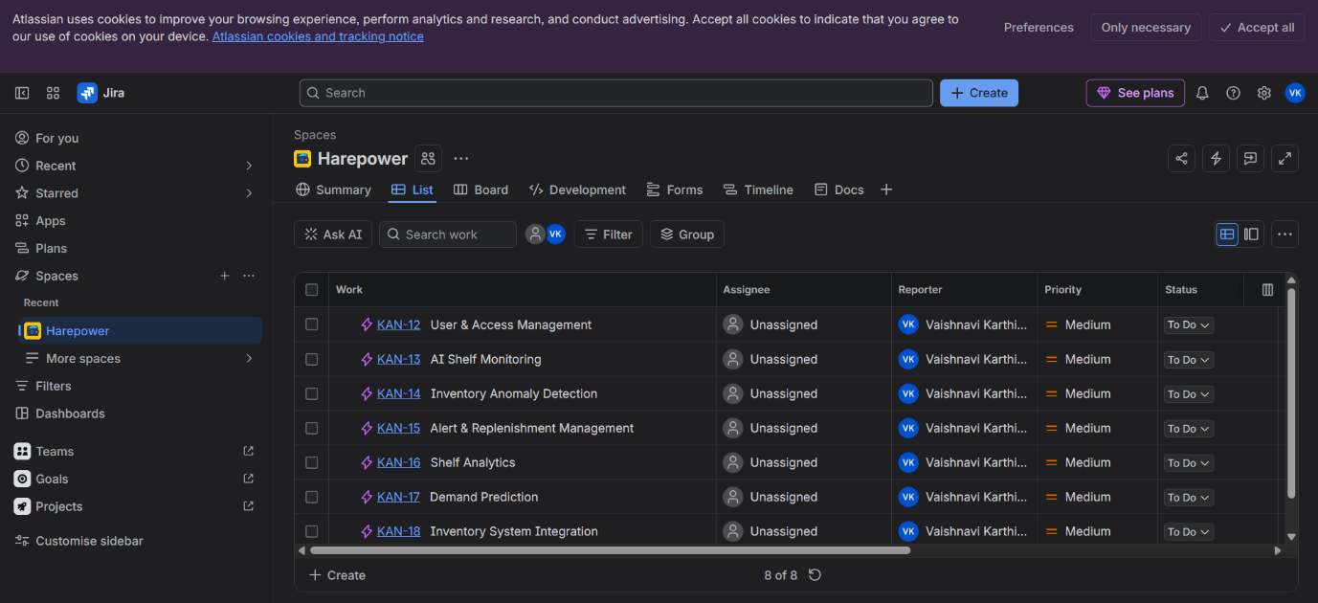

IMPLEMENTATION IN UMBRELLO:
CLASS DIAGRAM:
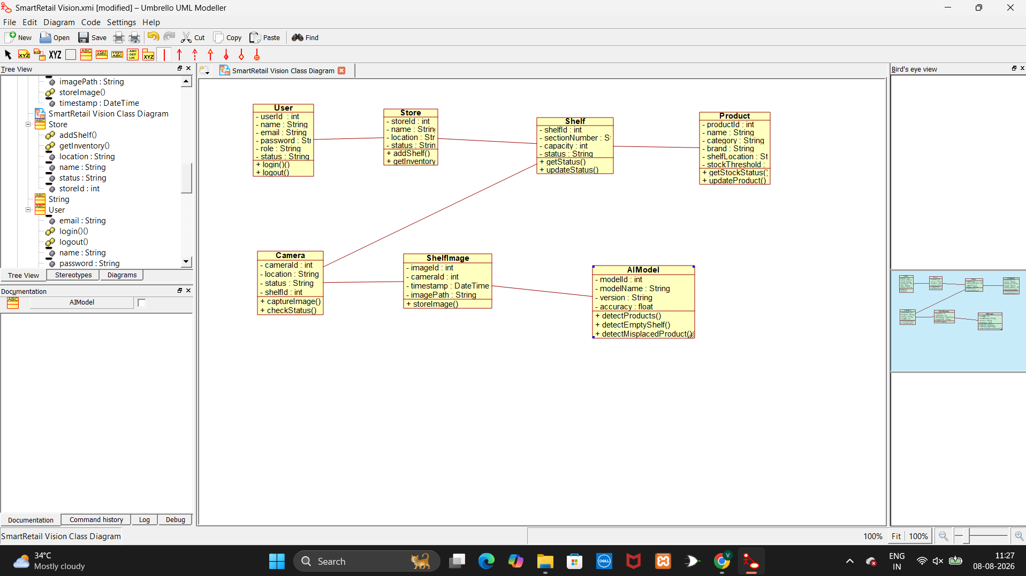

USE CASE DIAGRAM:
